# Connect the Raspberry Pi to the BME280

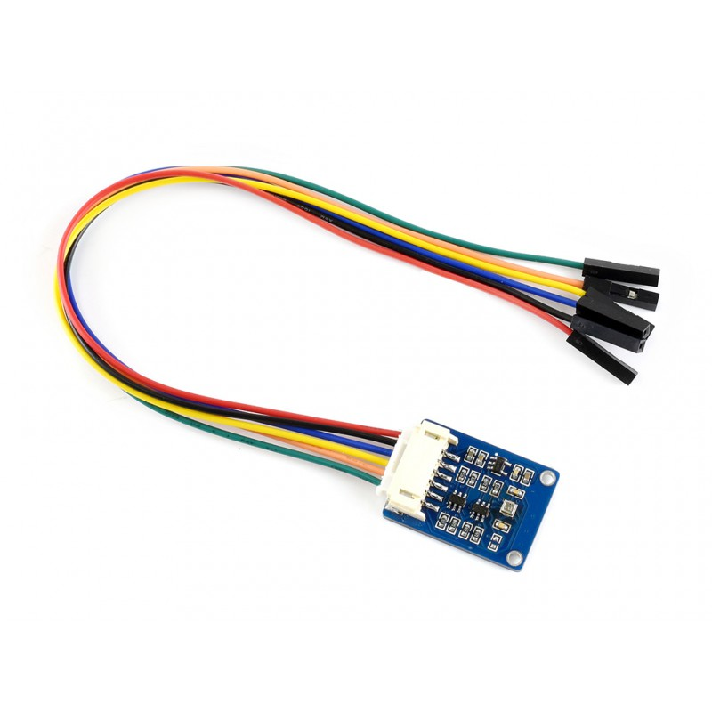

|  |  |  |  |  |
| --- | --- | --- | --- | --- |
| **Description** | **BME280 pinout** | **BME280 Wire Color** | **Raspberry Pi board pin** | **Raspberry Pi**  **Pin Description** |
| power | VCC | red | 1 | 3.3 vdc |
| ground | GND | black | 6 | ground |
| SPI data in | MOSI | blue | 19 | SPI0 MOSI  GPIO10 |
| SPI clock | SCK | yellow | 23 | SPI0 SCLK  GPIO11 |
| SPI data out | MISO | orange | 21 | SPI0 MISO  GPIO09 |
| SPI chip select | CS | green | 36 | Board 36  Wiringpi 27  Bcm 16  GPIO16 |